Player Name: | Career Highlights:
Ball, Matt  C 09 | It could very well be argued that Matt was one of the most complete and polished two way players to ever dress for Saint Vincent. Recruited heavily by Coach Ziemianski, Matt was a true hidden gem while playing for Wheeling Central Catholic High School. He made an immediate impact on the program and although was not selected to play in the CHE all star game, he was clearly better than most players from any of the other schools represented in the contest. Matt was a tireless worker, had a wonderful bench presence and a fantastic attitude. He could score just as easily on the back hand as he could around the net with well placed wrist shots. He was very strong in his own end and carried or passed puck with confidence. Matt came back strong the second semester of his sophomore campaign after practicing but not playing his first term due to an injury and was hoped to be a key in SVC’s run at a CHE title. But in a game well in hand over Penn State Behrend, a Lion player threw punches at Matt who, never dropping his gloves simply put up his hands to defend himself. On a very bad call by the officials, he was thrown out of the game for fighting and was made ineligible for the semi final playoff showdown against Cal. SVC lost an evenly played game by a Cal goal in overtime, without Matt who could have undoubtedly tipped the scales in favor of the Green and Gold. As an example of how his teammates and coaches felt about Matt, he was the first and only freshman in team history to receive the Fr. Herman Ubinger Award as the Team’s Unsung Hero for the 2005-2006 season.

Yr | # | Pos | GP | G | A | TP | S | Pct | + | - | +/- | PM | W | T | P | S
0506 | 77 | Rw | 24 | 25 | 21 | 46 | 83 | 30.1 | 50 | 18 | +32 | 28 | 0 | 0 | 3 | 1
0607 | 77 | Rw | 8 | 4 | 9 | 13 | 25 | 16.0 | 6 | 7 | -1 | 31 | 0 | 0 | 1 | 0
Totals |  |  | 32 | 29 | 30 | 59 | 108 | 26.9 | 56 | 25 | +31 | 59 | 0 | 0 | 4 | 1

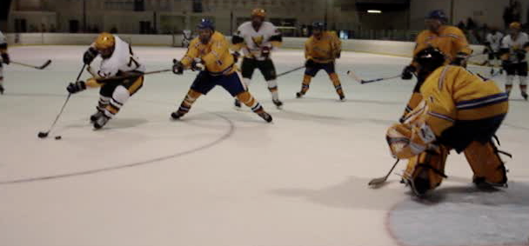
Matt excelled at protecting the puck. He scores on this backhand shot against WVU.
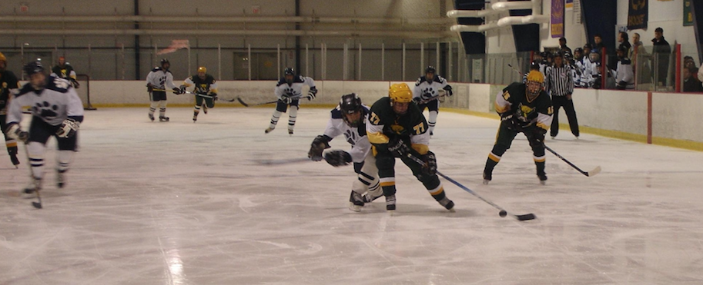

Of course if you thought it was tough to get the puck away from Matt on his backhand, just try to do it on his forehand. #15 Jim Mandel is ready for support.

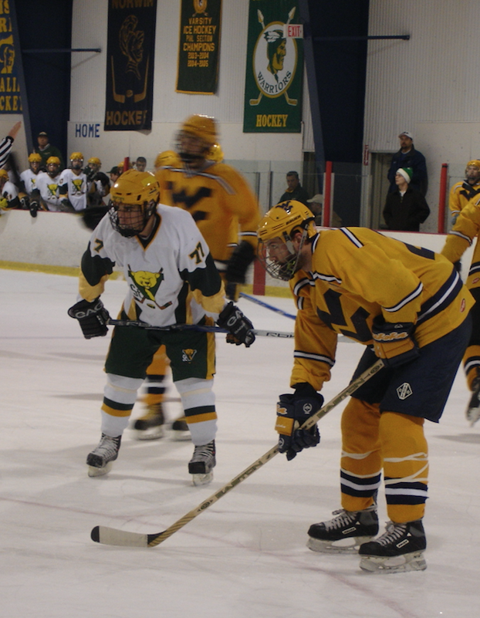
#77 Matt Ball lining up for a face off against WVU.

