Player Name: | Career Highlights:
Reinshagen, Al | Most players remember Al as the head coach of the team for 6 seasons, but during the early years of the program, lacking the all important experience in goal, Al volunteered to get the team off to a fast start by playing between the pipes. Al played goalie for the semi-pro Pittsburgh Knights and gets credit for recording the first victory for the team versus Duquesne University in the 1969-1970 campaign. Al managed the team to 34 victories during his tenure as head coach and was behind the bench for the famous playoff team that took a powerful Pitt squad into overtime before losing the game on a disputed goal. Years later he was still involved in the game by refereeing youth hockey games. After retiring, he joined St. Vincent and worked in the Chemistry Department and retuned to referee some of the early student alumni games. For his dedication, Al was named an honorary alumnus of the College by the Alumni Council. When the team reorganized in the 1999-2000 season, he became “Coach Reinshagen” once again by acting as the goalie coach. His coaching career will always be remembered for practice plans on 3” x 5” cards and the famous saying “Why not!”. Al passed away after the 2001-2002 season.

Yr | # | Pos | GP | G | A | TP | S | Pct | + | - | +/- | PM | W | T | P | S
6970 | 30 | G | 3 | 0 | - | 0 | - | - | - | - | - | - | 0 | 0 | - | -
7071 | 30 | G | 1 | 0 | - | 0 | - | - | - | - | - | - | 0 | 0 | - | -

Yr | # | Pos | GP | MP | GA | AVG | SO | EN | W | L | T | SHOTS | SAVES | PCT
6970 | 30 | G | 3 | 105 | 10 | 4.29 | 0 | 0 | 1 | 1 | 0 | - | - | -
7071 | 30 | G | 1 | 30 | 8 | 12.00 | 0 | 0 | 0 | 1 | 0 | 40 | 32 | .800
Totals |  |  | 4 | 135 | 18 | 6.00 | 0 | 0 | 1 | 2 | 0 | 40 | 32 | .800

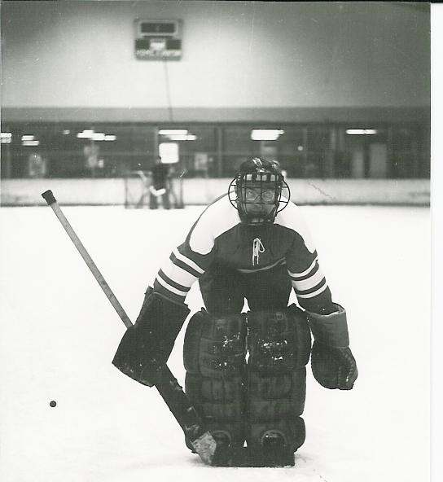
Al as a goaltender in the team’s first season, 1969 – 1970.
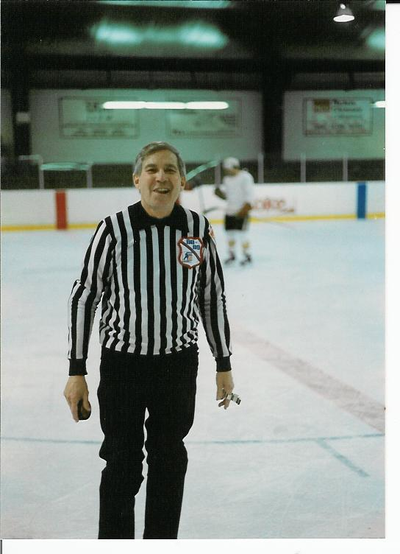
Why not! After finishing his playing and coaching career, Al dedicated his time to officiating youth hockey matches in Greensburg. He even worked the 1988 – 1989 alumni game!

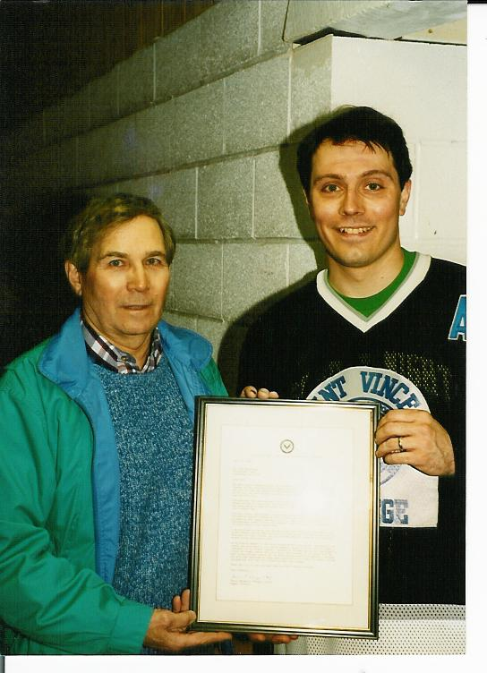

For his years of dedicated service to SVC and Amateur Hockey, the alumni council unanimously approved a resolution making Coach Al an honorary alumnus of the College. Mike Ziemianski, organizer of the alumni games and former player under Coach Reinshagen, presents Al with a letter signed by Fr. Herman Ubinger, O.S.B., then Alumni Director at Saint Vincent. The award was made at the 1989-1990 alumni game which was played as a tribute to the founders of the team 20 years earlier.

