Player Name: | Career Highlights:
Dolan, Craig  C’07 | Craig just kept getting better every season. He started as a solid two way winger and ended his career centering the first line. He had explosive acceleration and was a complete two way player. Some memorable moments of Craig’s career include: Coming off the bench his freshman year with the goalie pulled in the ACHA D III National Tournament and setting up Matt Ward for a game tying score against Richmond; Getting the game tying goal against a stubborn Hofstra team; Taking over a game with the finest example being a two goal effort against Penn State DELCO in a 4-2 SVC victory. He scored a key game winner his senior year against UPJ and became a member of the 20 goal club by notching the first score in a tough 4-3 overtime playoff loss against Cal U. Craig “snuck into” the 2005-2006 CHE All-Star game but made it official his senior season by representing SVC as one of the top players in the league. His leadership was rewarded with an assistant captain role his junior year and co-captain for his senior campaign. He was recognized with the Andy Vahaly Team Spirit Award in both his Junior and Senior years.

Yr | # | Pos | GP | G | A | TP | S | Pct | + | - | +/- | PM | W | T | P | S
0304 | 19 | Lw | 26 | 11 | 12 | 23 | 43 | 25.6 | 29 | 9 | +20 | 26 | 2 | 0 | 2 | 0
0405 | 19 | Lw | 25 | 14 | 16 | 30 | 66 | 21.2 | 29 | 15 | +14 | 78 | 3 | 0 | 2 | 1
0506 | 19 | Lw | 21 | 10 | 26 | 36 | 57 | 17.5 | 32 | 5 | +27 | 30 | 1 | 0 | 3 | 0
0607 | 19 | C | 24 | 20 | 27 | 47 | 88 | 22.7 | 33 | 22 | +11 | 55 | 2 | 0 | 8 | 0
Totals |  |  | 96 | 55 | 81 | 136 | 254 | 21.7 | 123 | 51 | +72 | 189 | 8 | 0 | 15 | 1

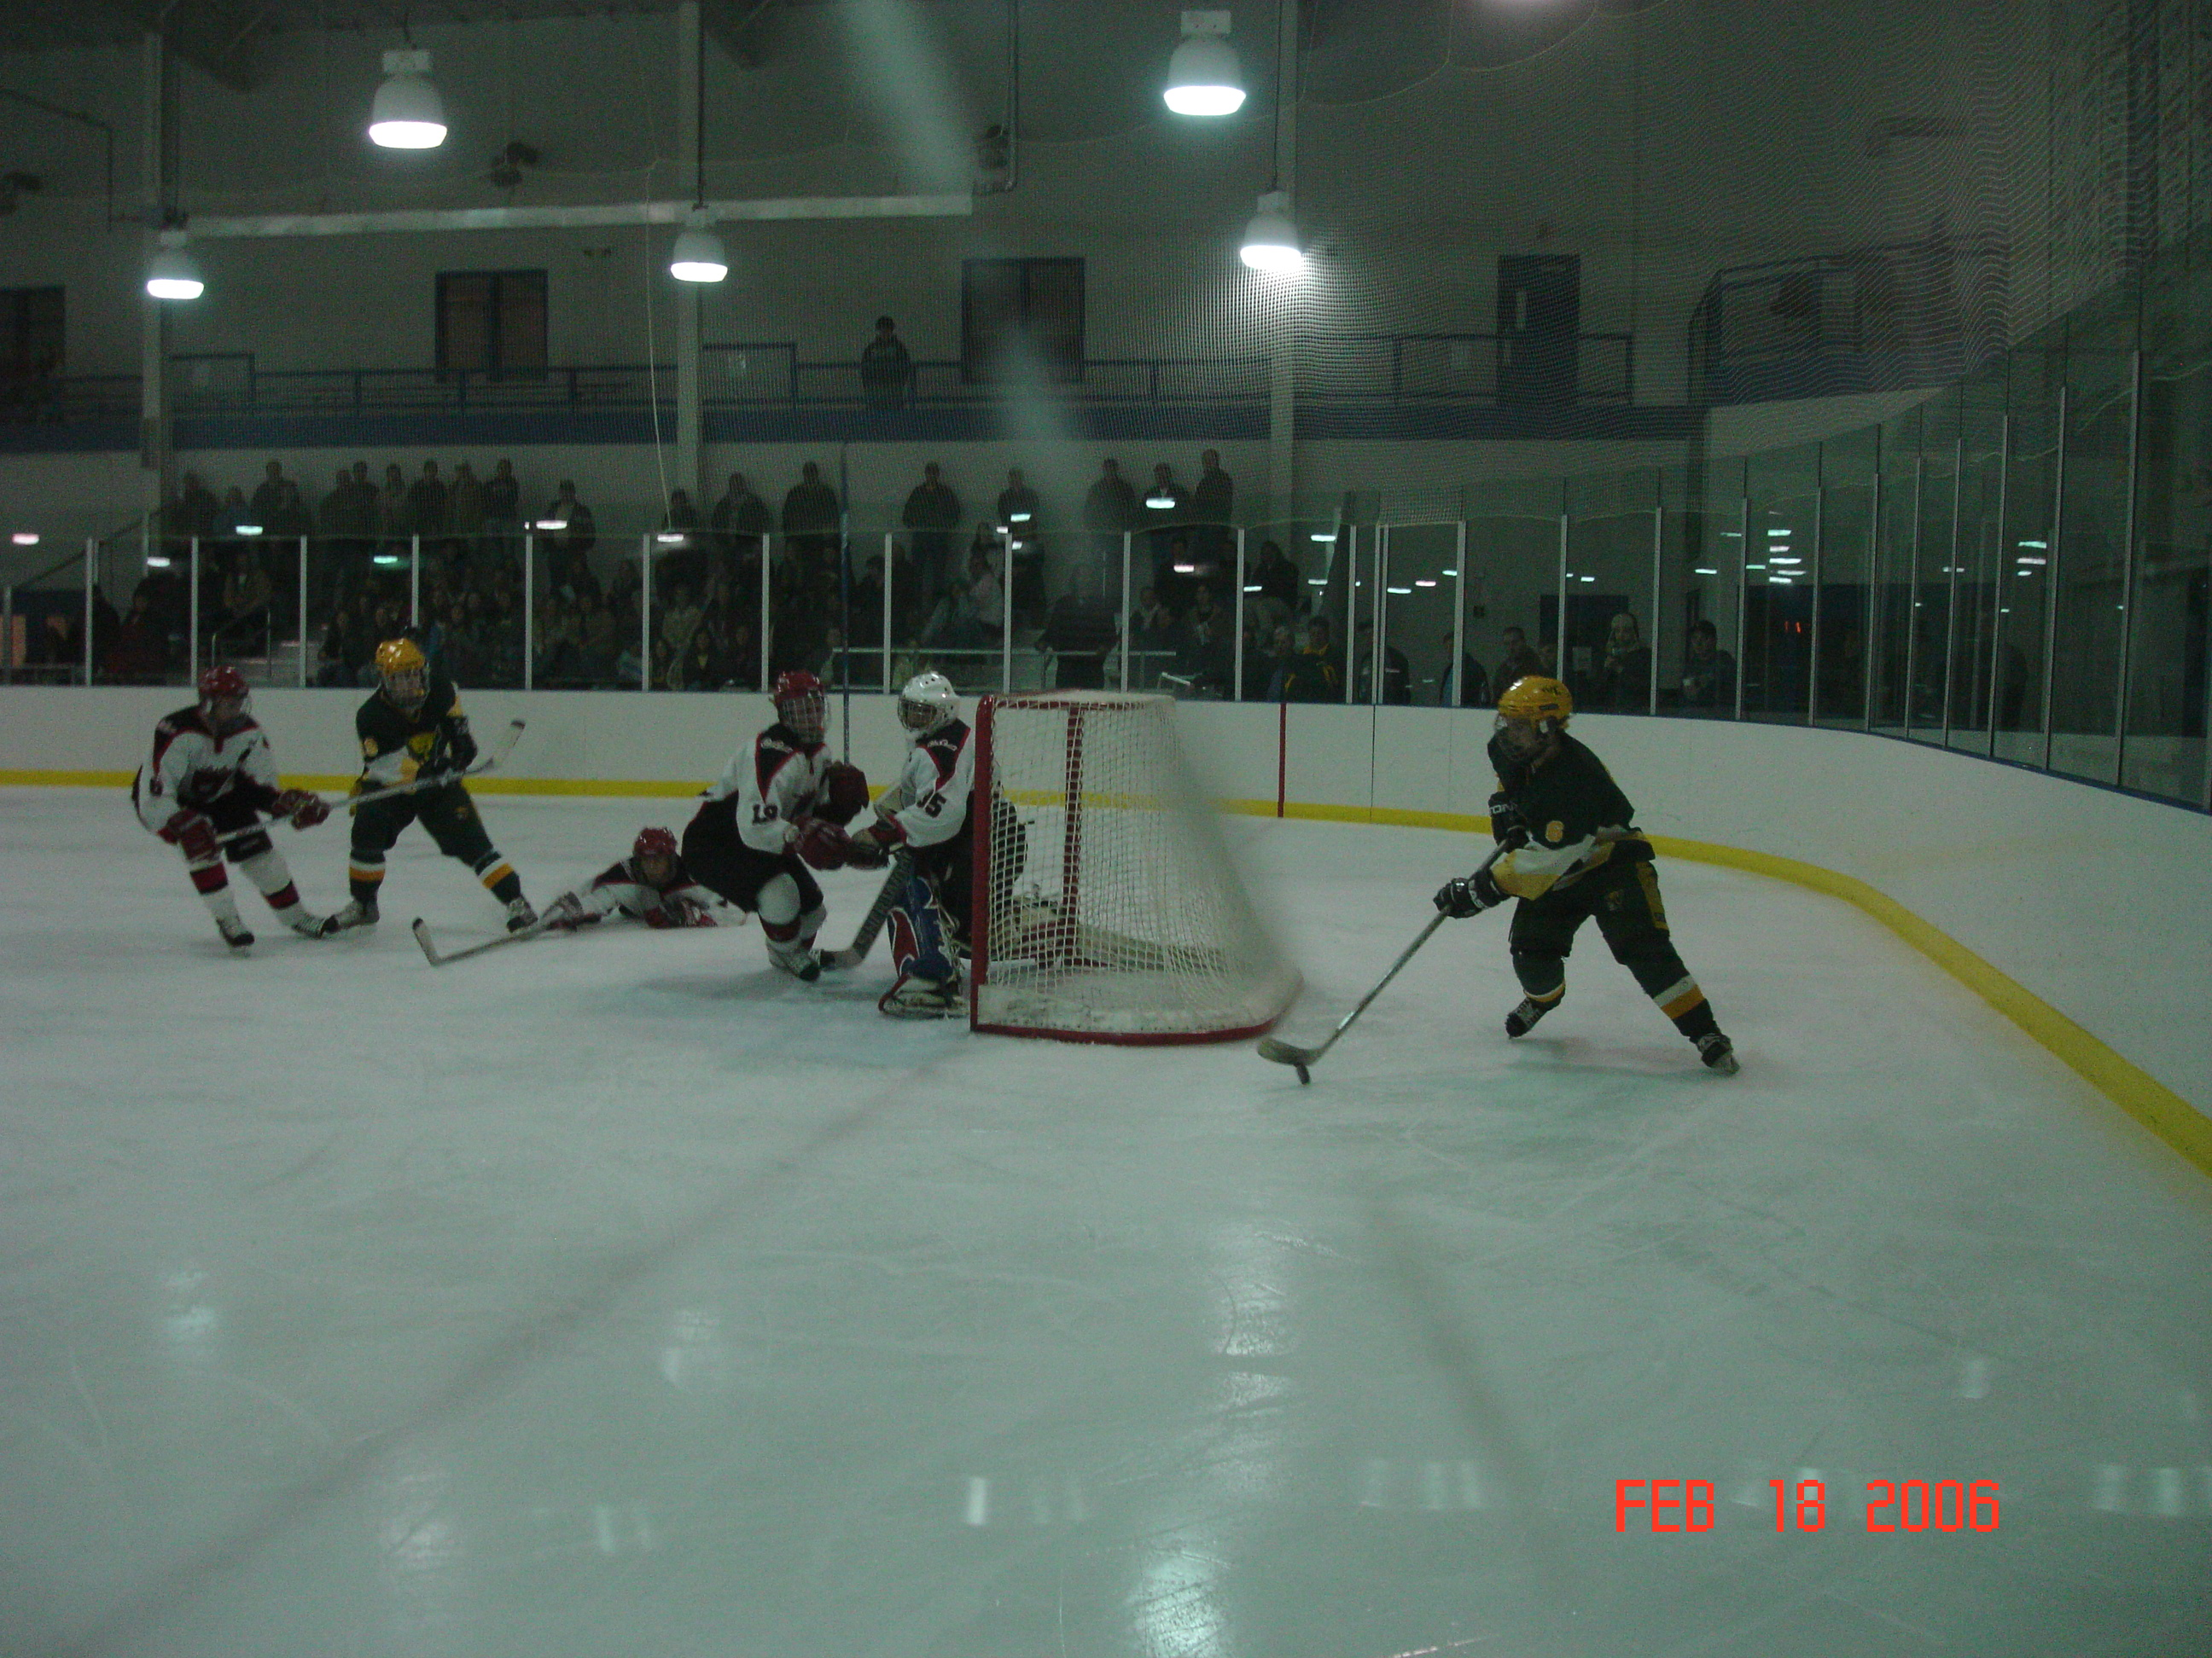
Craig in front of the Cal U net drawing two defenders while Matt Ward curls from behind the cage.

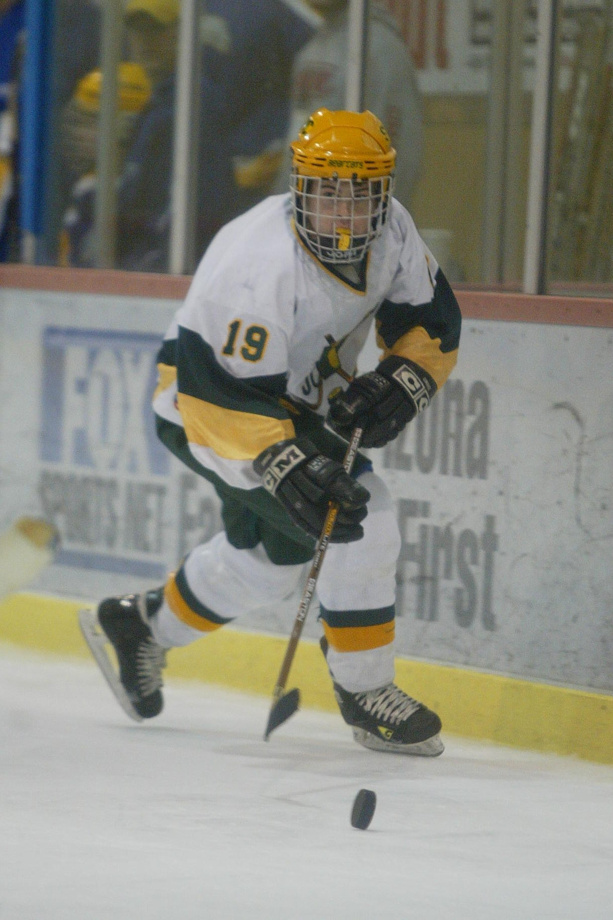
Craig controlling the puck during the 2003-2004 ACHA D III National Tournament in Phoenix Arizona.

