Player Name: | Career Highlights:
Doerr, Joe  C 76 | Joe was a hard nosed defenseman during his two seasons at the school who would think nothing of scrapping with the other team. He is credited with scoring the goal that sent SVC and Pitt into overtime during the championship game of the 1972-1973 season. He transferred after his Sophomore year. His younger brother, Rick played at St. Vincent in the late 1970’s and early 1980’s.

Yr | # | Pos | GP | G | A | TP | S | Pct | + | - | +/- | PM | W | T | P | S
7273 | 17 | D | 12 | 1 | 5 | 6 | - | - | - | - | - | 21 | 0 | 0 | 0 | 0
7374 | 17 | D | 19 | 5 | 5 | 10 | - | - | - | - | - | 45 | 1 | 0 | 2 | 0
Totals |  |  | 31 | 6 | 10 | 16 | - | - | - | - | - | 66 | 1 | 0 | 2 | 0

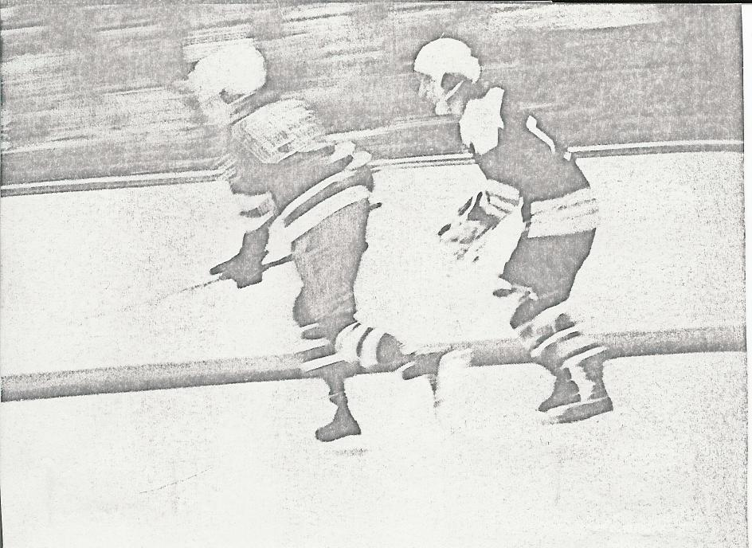

Joe Doerr (R) in action against Duquesne University during the 1973 1974 season.

